A DenseNet-CNN Framework for Non-Invasive Anemia Prediction Using Mediapipe-Based Feature Extraction

*V Harish,  
Department of Computer Science and Engineering,  
Kalasalingam Academy of Research and Education,  
Krishnankoil, Tamil Nadu, India  
9921004263@klu..ac.in.*

*K Janahan,  
Department of Computer Science and Engineering,  
Kalasalingam Academy of Research and Education,  
Krishnankoil, Tamil Nadu, India,  
9921004276@klu.ac.in.*

*M Abhilash,  
Department of Computer Science and Engineering,  
Kalasalingam Academy of Research and Education,  
Krishnankoil, Tamil Nadu, India,  
9921004002@klu.ac.in.*

*S Harish ,  
Department of Computer Science and Engineering,  
Kalasalingam Academy of Research and Education,  
Krishnankoil, Tamil Nadu, India,  
9921004879@klu.ac.in.*

***Abstract — In this paper we present a non-invasive method to detect anemia by estimating hemoglobin from visible areas like palms, eyelids and nails using CNN DenseNet. OpenCV does real time image processing, Mediapipe does precise palm landmark detection and Roboflow does nail and conjunctiva segmentation. This method eliminates blood testing and provides a quick, easy and effective screening option especially in resource constrained environments. This approach improves real time health checks and increases practicality and scalability of anemia detection.***

***Keywords: CNN, Mediapipe, Roboflow, OpenCV, DenseNet, real time processing, non-invasive anemia detection and easily accessible healthcare.***

1. INTRODUCTION

Anemia is a big global health problem especially in areas with limited healthcare infrastructure and access to traditional diagnostic tools. It affects millions of people worldwide, causing fatigue, weakness and cognitive impairment and can be severe if left untreated. Traditional anemia detection method relies on blood test to measure hemoglobin levels; but these are invasive, time consuming and require medical professionals and specialized laboratory equipment. In remote and resource poor setting, lack of access to such facilities hinders early diagnosis and intervention and increasesrisk of complications. This highlights the need for innovative non-invasive diagnostic alternatives that can detect anemia without blood sampling.

Recent progress in deep learning plus computer vision has improved medical diagnostics by allowing immediate image checks for disease detection. A useful method for anemia screening is to look at visible body parts such as nails, eyelids, palms that show clear color and texture differences with hemoglobin levels. With computer vision automated systems pick out features from these body parts without needing medical experts. This immediate check makes screening fast, affordable, scalable; it works well for large populations and use in areas without sufficient health services.

This study introduces a deep learning CNN model to detect anemia without drawing blood by using visual signs from key body parts. The system uses Mediapipe to mark palm features, Roboflow to separate nails with eye membranes plus OpenCV for immediate image preparation as well as review. We teach the CNN model with many labeled pictures to sort how bad anemia is based on chosen visible traits. With no blood tests this method gives a simple option that can grow to help many in places with few resources. Later sections explain the setup, data work, model setup as well as the effect of this test method on worldwide health care access along with early illness finding.

1. LITERATURE SURVEY

Anemia is a blood disorder that many people face. Experts have studied it with tools such as machine learning and deep learning. They used deep neural networks, picture analysis plus ways to pick out key details to make safe, quick tests for anemia. Problems with picture quality, high computer demands plus limited access block common use.

Zhao et al. [1] built ASModel_UWF, a deep learning model that uses ultra-wide-field fundus images to estimate hemoglobin content. The method works well but needs special imaging tools, which restricts its use in low-resource settings. Ramzan et al. [2] applied ML classifiers with attention features; they combined text and image data using an AlexNet Multiple Spatial Attention model. The idea works well yet greater computer demands create problems for real-time tasks.

Machine learning methods also used structured clinical data to classify anemia. Dhakal et al. [3] used ML classifiers such as decision trees, SVMs, Naïve Bayes. They reached promising results. Real-time use faced limits because of dataset issues and difficulty in selecting features. Zhang et al. [4] built a deep learning system that used facial images to predict anemia severity. Variations in lighting conditions, skin tone affected the model’s stability, its ability to apply to varied cases.

Emerging point-of-care (POC) technologies were also studied for anemia detection. An et al. [5] examined methods that hurt the body little or not at all noting that portable hemoglobin meters, electrochemical sensors plus smartphone-based detection tools show promise. Saputra et al. [6] suggested an Extreme Learning Machine (ELM) model for anemia classification but noted that large sets of labeled data are needed for best results. Tamir et al. [7] used a method that processes images with simple threshold techniques on conjunctival pictures. Although this option cost little, the model did not use deep learning to pick details for better accuracy.

Smartphone methods were tried for anemia detection without using needles. Mannino et al. [8] built a phone app that examines the nail bed. This method is easy to reach but needs specific light and custom setup, which limits its wider use. Khusun et al. [9] checked WHO hemoglobin levels for anemia in Indonesia showing good true positive and true negative rates yet no use of AI detection models. Hasan et al. [10] studied DenseNet CNNs for medical images to predict disease, though these models need powerful computer parts, which makes quick use hard.

Despite these advancements, significant challenges persist in developing AI-driven anemia detection systems. Key issues include dependence on high-quality imaging, computational resource constraints, sensitivity to environmental factors, and the need for diverse datasets to enhance model generalization. Additionally, integrating AI models with existing POC technologies remains a challenge, requiring further research on real-time adaptability and clinical validation across diverse populations.

The proposed **"DeepNet-CNN Approach for Anemia Diagnosis with Mediapipe-Based Feature Analysis"** aims to address these limitations by leveraging real-time feature extraction, lightweight CNN architectures, and multi-modal fusion techniques. By incorporating advanced signal processing, improved image preprocessing, and robust ML models, this approach seeks to enhance accuracy, accessibility, and scalability in anemia screening, particularly in resource-constrained environments.

1. METHODOLOGY

The proposed methodology for real-time anemia detection involves three primary stages: (i) Palm, Nail, and Conjunctiva Extraction, (ii) Deep Learning-Based Feature Extraction and Classification, and (iii) Real-Time Deployment. The system employs Mediapipe for palm region extraction, Roboflow for nail and conjunctiva segmentation, and DenseNet-121 for classification. The workflow ensures efficient and accurate anemia detection by leveraging deep learning and computer vision techniques.

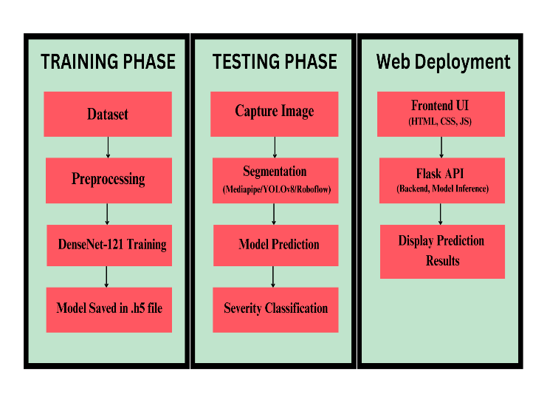

*Fig 1: Overall Model Architecture*

A. Data Collection and Preprocessing

The dataset comprises 2000 images each of palm, nail, and conjunctiva, categorized into anemic and non-anemic classes. Each image is resized to 128 × 128 pixels to maintain uniform input dimensions. Normalization is applied by scaling pixel values to the range [0,1] to stabilize model convergence. To enhance model generalization, data augmentation techniques such as rotation, brightness adjustment, flipping, and contrast enhancement are applied. The processed images serve as input to the feature extraction and classification pipeline.

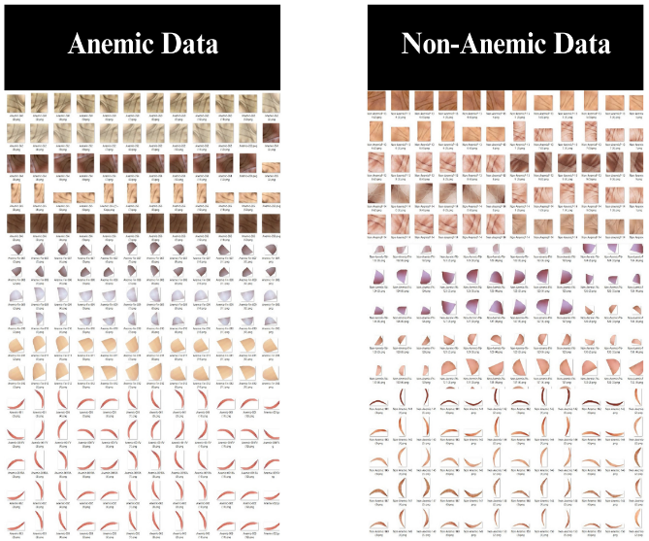

*Fig 2: Anemic and Non-Anemic Dataset*

B. Palm Detection and Region Extraction

The palm detection and region extraction process begins with Mediapipe Hands, a real-time hand-tracking framework capable of detecting 21 key hand landmarks. The wrist (landmark 0) and finger bases (landmarks 5, 9, 13, and 17) are utilized to form a convex hull, effectively isolating the palm region. Hand openness is determined using the Euclidean distance between the wrist and fingertips to ensure that the palm is fully visible. To maintain consistency in image quality, brightness is analyzed, and dynamic adjustments are made to ensure proper lighting conditions. Additionally, the palm's orientation is identified based on the relative positions of key landmarks to distinguish between the dorsal and palmar sides. If the palmar side is detected, a polygonal mask is generated around the palm using convex hull approximation and applied to remove background interference. The extracted palm region is then cropped using bounding box techniques to retain only the essential hand features. This refined palm image is subsequently stored for further analysis in anemia classification, ensuring accurate feature extraction while minimizing noise.

C. Nail and Conjunctiva Segmentation

To accurately assess anemia, segmentation of the nail and conjunctiva regions is performed using deep learning-based object detection models. The nail region is detected by applying a YOLOv8-based model trained on labeled fingertip images, ensuring precise localization. The detected nails are extracted and processed for further classification. Similarly, the conjunctiva region is segmented using a specialized YOLOv8 model trained for inner eyelid detection. Polygon-based segmentation is employed to refine the extracted conjunctiva region before proceeding with classification.

The extracted nail and conjunctiva regions serve as critical inputs for the anemia classification model. These segmented regions are analyzed to determine anemia severity, categorized into different levels based on visual characteristics. This approach enhances detection accuracy by leveraging deep learning techniques for feature extraction and segmentation.

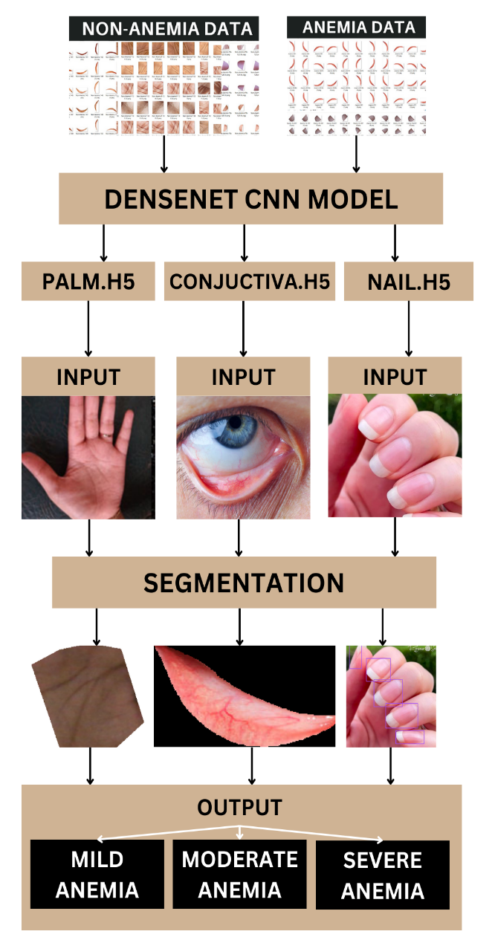

Fig 3:

D. Anemia Classification Using DenseNet-121

The classification model is based on DenseNet-121, a Densely Connected Convolutional Network (CNN), chosen for its efficient gradient propagation and feature reusability. Unlike traditional CNNs, DenseNet-121 connects each layer to every other layer in a feed-forward manner, enhancing feature learning and reducing the number of parameters. The model architecture comprises four dense blocks, each consisting of 1×1 and 3×3 convolutional layers. The final classification layer applies a softmax activation function to output the probability of anemia presence.

During training, the model utilizes the Adam optimizer with a learning rate of 0.0001 and binary cross-entropy loss function to minimize classification error. The dataset is split into 80% training and 20% testing, and the model is trained for 50 epochs with a batch size of 32. The Global Average Pooling layer converts the extracted feature maps into a one-dimensional vector, which is then passed through fully connected layers for final classification. A probability threshold is used to classify anemia severity based on prediction values. If the predicted probability is ≥0.8, the condition is classified as Severe Anemic; for values in the range 0.6 to 0.8, it is labeled as Moderate Anemic; predictions between 0.4 and 0.6 indicate Mild Anemic, while values <0.4 correspond to a Non-Anemic status.

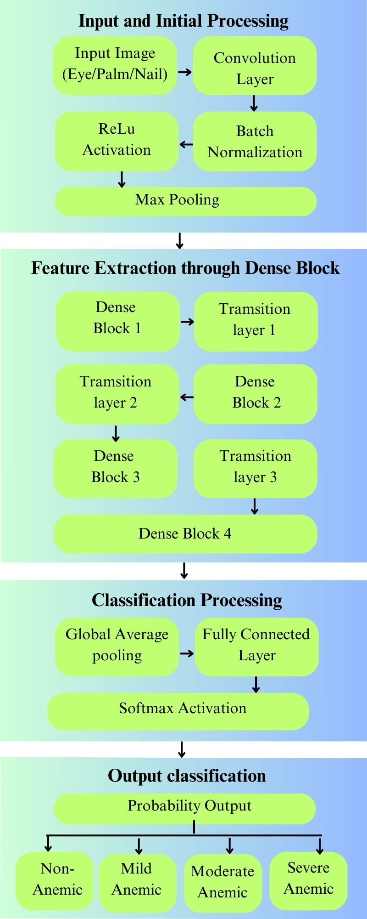

Fig 4:

E. Deployment and Real-Time Execution

For real-time analysis, the trained model is deployed using OpenCV and a webcam-based inference system. The captured image undergoes preprocessing, including segmentation and resizing, before being fed into the DenseNet-121 classifier. The final prediction is displayed in real-time, categorizing anemia severity into Severe Anemic, Moderate Anemic, Mild Anemic, or Non-Anemic based on the predicted probability. The proposed system provides a rapid, non-invasive, and accurate approach for anemia detection based on visual cues.

1. IMPLEMENTATION
2. Technologies Used

The system leverages a combination of deep learning frameworks, computer vision techniques, and web technologies for seamless operation. The primary technologies used include:

* Python: The core programming language for model development and backend logic.
* TensorFlow and Keras: Frameworks used for developing the deep learning model based on DenseNet architecture.
* Roboflow: Utilized for dataset preprocessing and annotation, specifically for eye and nail image segmentation.
* Mediapipe: A real-time hand and face tracking library used for extracting palm images and performing real-time segmentation.
* Flask: A lightweight web framework for handling API requests and integrating the model with the frontend.
* JavaScript, HTML, and CSS: Technologies used to design an interactive web interface for user engagement.
* IP Webcam App: A mobile application that broadcasts live video using an IP address, enabling real-time image acquisition for palm analysis.

1. Data Processing and Predictive Modeling

The data processing pipeline is designed to ensure high-quality inputs for training the anemia detection model. The dataset, comprising 2000 images each for eye, palm, and nail, undergoes extensive preprocessing to enhance consistency and reliability. Roboflow is utilized for eye and nail image segmentation, allowing precise annotation and dataset refinement. This ensures that the model learns from well-structured, noise-free data. Meanwhile, Mediapipe facilitates real-time palm segmentation from live video streams, extracting high-resolution frames that are subsequently fed into the model. The preprocessing phase includes resizing, normalization, and augmentation techniques such as rotation, flipping, and contrast adjustment to improve model generalization.

For predictive modeling, the DenseNet-121 architecture is selected due to its efficient feature propagation and reduced computational cost. DenseNet-121 employs densely connected convolutional layers, where each layer receives feature maps from all preceding layers, promoting gradient flow and preventing information loss. The model is initialized with pre-trained ImageNet weights and fine-tuned for anemia classification. A global average pooling layer replaces fully connected layers to minimize overfitting, followed by a softmax activation function for binary classification. The training phase incorporates an adaptive learning rate, batch normalization, and dropout regularization to enhance stability. Model performance is rigorously evaluated using accuracy, precision, recall, and F1-score, ensuring robust and reliable anemia detection across diverse image inputs.

1. Backend Logic

The backend is responsible for handling model inference requests, processing input images, and returning predictions to the frontend. It is structured to support real-time processing with minimal latency.

Flask API serves as the central communication bridge, receiving image inputs from the frontend, processing them through the CNN model, and returning the anemia detection results. The trained DenseNet model is loaded into the backend, optimized for efficient real-time inference. The system also incorporates real-time image acquisition for palm analysis, where the IP Webcam app streams live video from a mobile phone’s camera to a designated IP address. The backend extracts frames from this video feed at regular intervals, processing them for anemia detection.

Additionally, a database module is included (if applicable) to store user data and past detection results, enabling data logging and further analysis. This structured backend design ensures smooth interaction between different system components, supporting real-time anemia detection with high accuracy.

1. Frontend Integration

The frontend interface is designed to provide an intuitive and user-friendly experience. Built using HTML, CSS, and JavaScript, it allows users to interact seamlessly with the anemia detection system.

Users can either upload images or utilize the real-time processing feature for anemia analysis. The frontend supports real-time image acquisition via the IP Webcam app, enabling users to capture and transmit live video from their mobile devices. Extracted frames are then sent to the backend for inference. API communication ensures smooth data exchange between the frontend and backend, enabling users to receive prompt detection results.

The results are presented in an easy-to-understand format, displaying anemia detection outcomes along with confidence scores and recommendations. The interface is designed for accessibility, ensuring that users with minimal technical knowledge can operate the system efficiently.

This multi-layered implementation ensures that the system functions efficiently, delivering real-time anemia detection with high accuracy while providing a seamless user experience.

1. REFERENCE

[1] X. Zhao, L. Meng, H. Su, B. Lv, C. Lv, G. Xie, and Y. Chen, "Deep-Learning-Based Hemoglobin Concentration Prediction and Anemia Screening Using Ultra-Wide Field Fundus Images," *Frontiers in Cell and Developmental Biology*, vol. 10, 2022.

[2] M. Ramzan, J. Sheng, M. U. Saeed, B. Wang, and F. Z. Duraihem, "Revolutionizing anemia detection: Integrative machine learning models and advanced attention mechanisms," *Visual Computing for Industry, Biomedicine, and Art*, vol. 7, no. 18, 2024.

[3] P. Dhakal, S. Khanal, and R. Bista, "Prediction of Anemia Using Machine Learning Algorithms," *International Journal of Computer Science and Information Technology*, vol. 15, no. 1, pp. 15-23, 2023.

[4] A. Zhang et al., "Prediction of anemia using facial images and deep learning technology in the emergency department," *Frontiers in Public Health*, vol. 10, 2022.

[5] D. C. E. Saputra, K. Sunat, and T. Ratnaningsih, "A New Artificial Intelligence Approach Using Extreme Learning Machine as the Potentially Effective Model to Predict and Analyze the Diagnosis of Anemia," *Healthcare*, vol. 11, no. 697, 2023.

[6] A. Tamir et al., "Detection of Anemia from Image of the Anterior Conjunctiva of the Eye by Image Processing and Thresholding," *IEEE Region 10 Humanitarian Technology Conference*, 2017.

[7] R. G. Mannino et al., ", vol. 9, no. 4924, 2018. Smartphone app for non-invasive detection of anemia using only patient-sourced photos," *Nature Communications*

[8] H. Khusun et al., "World Health Organization Hemoglobin Cut-Off Points for the Detection of Anemia Are Valid for an Indonesian Population," *Journal of Nutrition*, vol. 129, pp. 1669-1674, 1999.

[9] R. An, Y. Huang, Y. Man, and U. Gurkan, “Emerging Point-of-Care Technologies for Anemia Detection,” Lab Chip, vol. 21, no. 10, pp. 1843–1865, 2021.

[10] N. Hasan, Y. Bao, A. Shawon, and Y. Huang, "DenseNet Convolutional Neural Networks Application for Predicting COVID-19 Using CT Image," *SN Computer Science*, vol. 2, no. 389, 2021.